11i Cost Cutoff Date to Retroactively Cost Transactions

Eric Guether
Opnext, Inc.
eguether@opnext.com

Introduction

This white paper explains how to use the cost cutoff date functionality in EBS 11i to defer the costing of transactions for several days or longer while an inventory organization updates its frozen costs. Once cost updates have completed, any uncosted transactions will, essentially, be valued retroactively using the new frozen costs. The cost cutoff date is an optional inventory organization parameter whose functionality was introduced in release 11.5.7.

Examples presented in this paper include a Miscellaneous Receipt transaction in 11i Inventory, a PO Receipt directly into inventory, and a Work Order-less Completion in 11i WIP. The impact of the cost cutoff date on historical inventory balance reports and the intercompany invoicing process is also addressed.

Business Case

Opnext’s company practice is to update standard costs every six months as of April 1st and October 1st. The new costs should apply to all transactions in the cost period, for example, from April 1, 2006 to September 30, 2006, or from October 1, 2006 to March 31, 2007, etc. But the new costs are typically not finalized until a few days into the new cost period. Opnext usually does not complete its standard cost updates until around April 10th or October 10th. However, all material transactions dated in April or October needed to be valued at the new costs, even though those new costs are not updated to become the frozen, or current, costs until the second or third week in April or October.

The dilemma facing Opnext before release 11.5.7, therefore, was how to record early April or October Inventory, WIP, and PO Receiving transactions (quantities) in the new cost period before the standard cost updates. Opnext needed to cost, or value, those transactions after the standard cost update at the new frozen standard costs. Opnext could not simply shut off the Cost Manager for a few weeks starting on April 1st or October 1st, because any late March or September transactions created in early April or October needed to be valued at the current old period costs prior to the standard cost updates.

Opnext’s factories and warehouses had developed a workaround for two years while Opnext remained on 11.5.3. Users would record inventory, WIP, shipping and PO receiving transactions offline – outside of EBS 11i – on spreadsheets from April 1st, or October 1st, until the standard cost updates were completed. Then users would retroactively record those transactions in EBS 11i after the standard cost updates so that transactions were valued with the new frozen costs. But retroactive transaction entry raised many issues:

- Unnecessary control weaknesses.
- Risk of data inaccuracy.
- Extra, unnecessary data entry for users.
- Unreliable inventory quantities in EBS 11i for a week or more.
- Manual preparation of shipping and export documents – not via EBS 11i – for a week or more.

Opnext needed Oracle’s standard costing functionality to be more flexible to allow material transactions in the new cost period to remain uncosted until Opnext was ready to perform its standard cost updates. Oracle added this functionality in release 11.5.7 with the introduction of the cost cutoff date.
The Solution: Cost Cutoff Date

The cost cutoff date functionality is designed around an optional date parameter on the inventory organization’s Costing tab (refer to Figure 1 below).

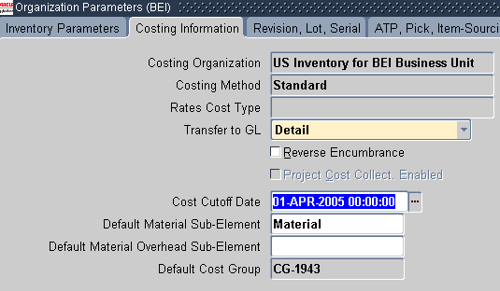
Figure 1 – Inventory Organization Costing Parameters

The cost cutoff date functionality essentially stops material transactions in the organization from being costed if their transaction date is on or after the cutoff date. Any transactions dated before the cost cutoff date will be costed using the current frozen costs, even if such transactions were created after the cutoff date. All transactions dated on or after the cost cutoff date remain uncosted until the cost cutoff date is changed to a future date. The idea is that an inventory organization would not push its cost cutoff date to a future date until it completes its standard cost updates.

The cost cutoff date can be used for all perpetual costing methods in EBS 11i, including standard costing, average costing, FIFO, and LIFO. The scope of this white paper is limited to standard costing.

The cost cutoff date functionality can be used most effectively in conjunction with the timing of a standard cost update. This is accomplished by setting a cutoff date to the first day on which the new costs should be effective, for example, April 1, 2005. Then a typical standard cost update sequence would be:

- Complete all March 2005 transactions by early April [valued at current frozen costs = old period costs] and Begin entry of April-dated transactions on April 1, 2005 [costing deferred by the cutoff date].
- Close the March 2005 inventory period for the organization in early April.
- Perform standard cost updates for the organization in early to mid-April.
- Change the cost cutoff date for the organization to a later date, such as 01-OCT-2005.
- The Cost Manager then costs all existing April 2005-dated transactions at the current, updated frozen costs [new period costs].

From a database perspective, when the cutoff date defers costing of a transaction, transaction entry still inserts a record on the MTL_MATERIAL_TRANSACTIONS table. This allows transaction quantities to be recognized by the EBS 11i modules. But the record’s COSTED_FLAG column has a value of ‘N’, indicating that the record has not yet been costed and that no accounting entries, or distributions, have been created.
The cost cutoff date can delay the costing of many types of transactions across EBS 11i modules. Some primary examples are shown below in Figure 2 (not a complete list):

Module | Transaction
Inventory | Miscellaneous / Account Alias Receipt
Inventory | Miscellaneous / Account Alias Issue
Inventory | Subinventory Transfer
Inventory | Interorg Transfer
Inventory | Receiving
Inventory | Pick Confirm
Inventory | Ship Confirm / Sales Order Issue
Inventory | Create Intercompany AR Invoices
Purchasing | PO Receiving (including PPV)
Purchasing | Return to Supplier
Work in Process | Discrete WIP Assembly Completion
Work in Process | Discrete WIP Component Issue
Work in Process | Work Order-less Completion
Figure 2 – Partial List of Transaction Types whose Costing is Deferred by Cost Cutoff Date

Example # 1: INV Miscellaneous Receipt – No Costing Deferred

In this scenario, the cost cutoff date will not defer costing of the material transaction. A miscellaneous receipt will record the receipt of 10 units of item LASER123. This item’s standard cost is intended to be $1,200 per unit for transactions through the end of March 2005 and $1,000 starting April 1, 2005. The standard cost for LASER123, however, will not be updated to $1,000 until April 4, 2005. The transaction date of the receipt is 31-MAR-2005, which is before the cutoff date of 01-APR-2005. The creation date of the transaction is 01-APR-2005, which is on the cutoff date.

Figure 3 shows the transaction for Example # 1:

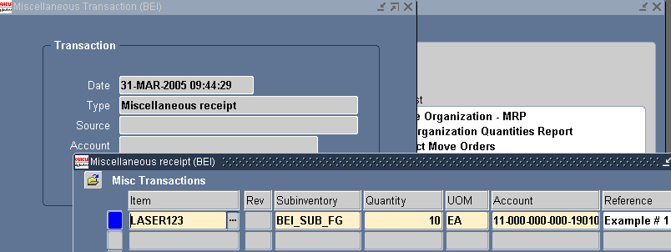
Figure 3 – Example # 1: Miscellaneous Receipt (No Costing Deferred)

The chart in Figure 4 below shows that the 10 units received are costed upon entry at the old period cost of $1,200 per unit. Transaction costing is not deferred, because the transaction date is before the cost cutoff date. The creation date of the transaction does not matter as long as the required inventory organization period is still open. The transaction is costed at the old period cost of $1,200, because it is still the current frozen cost on April 1st; the standard cost update will occur later on April 4th. Material distributions are created on April 1st as soon as the transaction is costed.

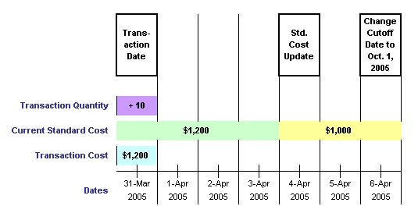
Figure 4 – Example # 1: Miscellaneous Receipt (No Costing Deferred)

Example # 2: INV Miscellaneous Receipt – Costing Deferred

This scenario is similar to Example # 1 except that the transaction date is 01-APR-2005, which is the same as the cost cutoff date. Therefore, the cutoff date will defer the costing of the material transaction. A miscellaneous receipt will record the receipt of 5 units of item LASER123. The standard cost for LASER123 will not be updated to $1,000 until April 4, 2005. Figure 5 shows the transaction for Example # 2:

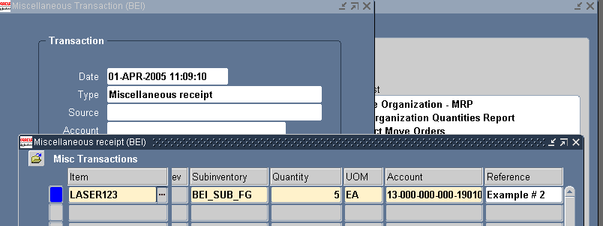
Figure 5 – Example # 2: Miscellaneous Receipt (Costing Deferred)

Figure 6 shows the standard cost update run on April 4, 2005 to update the cost for LASER123 from $1,200 to $1,000:

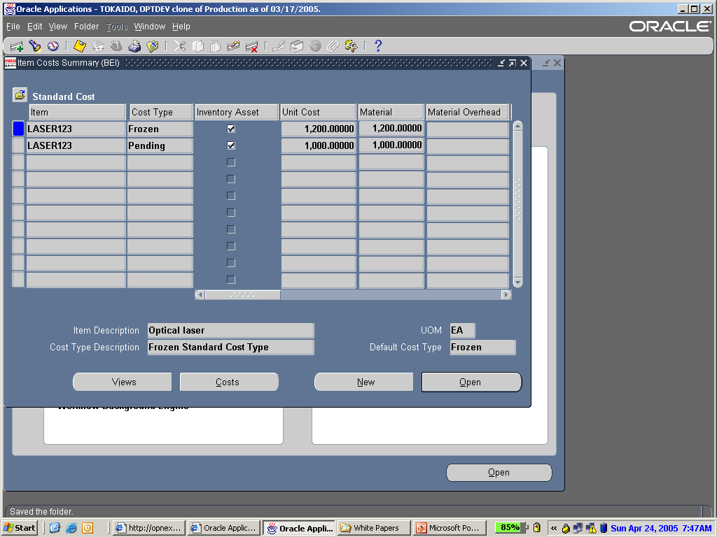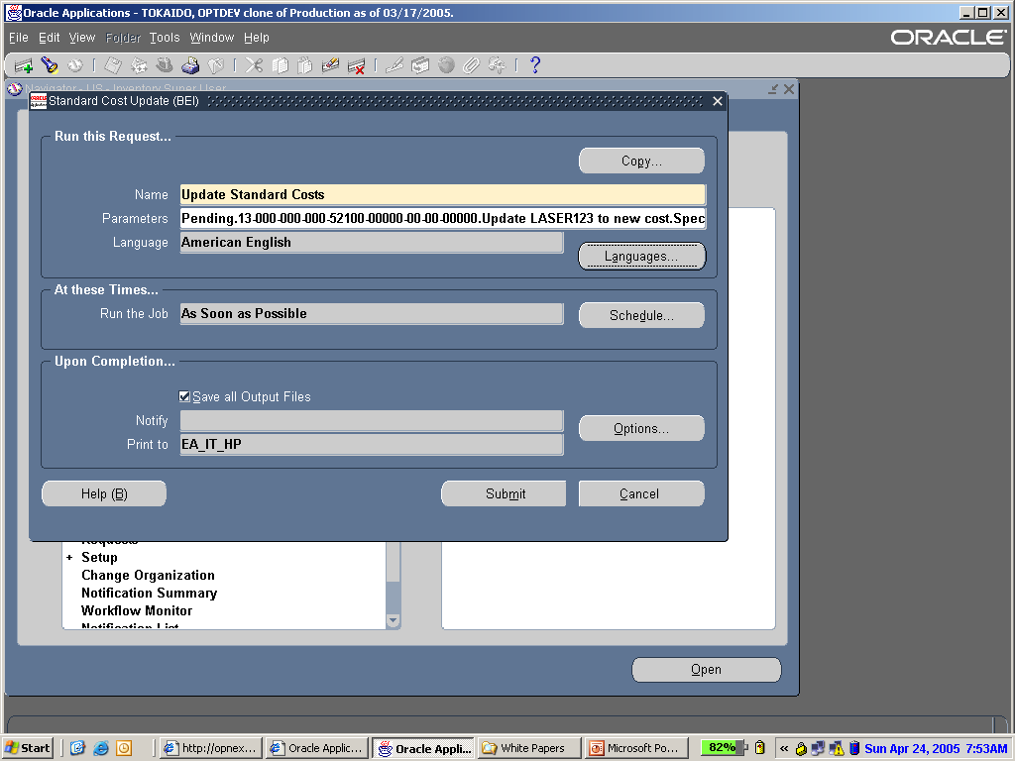
Figure 6 – Item Cost Summary and Standard Cost Update

The cost cutoff date for the organization is then changed on April 6, 2005 from 01-APR-2005 to 01-OCT-2005 as shown in Figure 7:

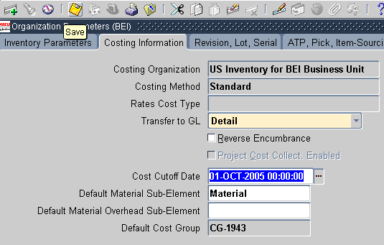
Figure 7 – Changing the Cost Cutoff Date Value

Receipt of the 5 units is recorded immediately upon entry but remain uncosted until April 6th as depicted in the chart shown in Figure 8. Costing is deferred, because the transaction date is on the cost cutoff date. The creation date of the transaction does not matter, since the April 2005 inventory period is open. The transaction is costed on April 6th at the new period cost of $1,000, since that is the item’s frozen standard cost on April 6th.
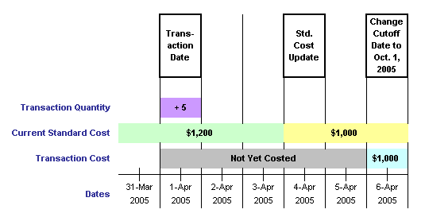
Figure 8 – Example # 2: Miscellaneous Receipt (Costing Deferred)

Material distributions, as shown in Figure 9, are created on April 6th as soon as the transaction is costed.

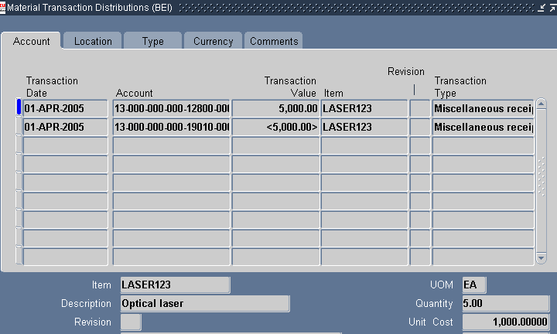
Figure 9 – Accounting Distributions for Example # 2: Misc. Receipt (Costing Deferred)

Example # 3: PO Receiving into Inventory – Costing Deferred

In this example, 200 units of DIODE-5002 will be received directly into inventory through a PO Receipt in the Purchasing module. The PO price of the item is $0.90. Its standard cost is $1.25 through the end of March 2005 and $1.00 starting on April 1st. The cost for DIODE-5002 will not be updated to $1.00 until April 4th. The transaction date of the receipt is 02-APR-2005, which is after the cutoff date of 01-APR-2005. The transaction is shown in Figure 10:

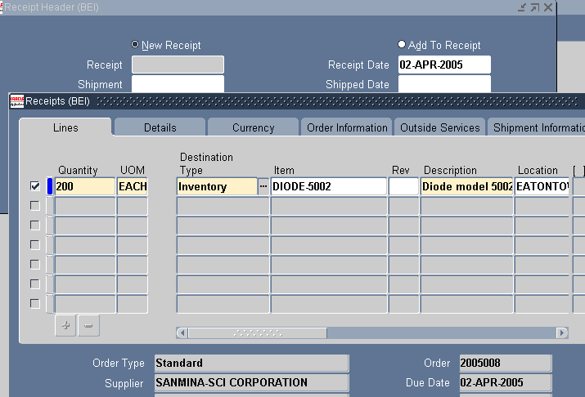
Figure 10 – Example # 3: PO Receipt into Inventory (Costing Deferred)

The receipt of 200 units is recorded upon entry but remains uncosted until April 6th as depicted in the Figure 11 chart. Costing is deferred, because the transaction date is after the cost cutoff date. The transaction is costed at the new period cost of $1.00 on April 6th, because that is the frozen cost on April 6th.

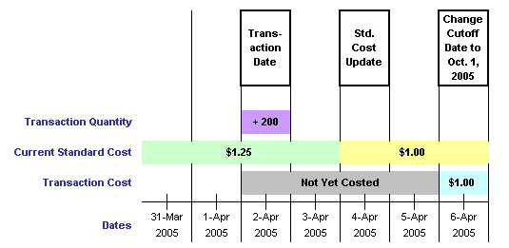
Figure 11 – Example # 3: PO Receipt into Inventory (Costing Deferred)
When the material distributions are created on April 6th, a favorable purchase price variance (PPV) will be calculated at $0.10 per unit or $20.00 in total. This PPV is the difference between the PO price of $0.90 and the new standard cost of $1.00 – not the old period cost of $1.25 that was the frozen cost when the transaction was created.

Example # 4: Work Order-less Completion – Costing Deferred

This example uses a Work Order-less Completion transaction in the Work in Process (WIP) module to show that the cost cutoff date can impact WIP transactions. Opnext records Work Order-less Completions with a “WIP Assembly Completion” transaction type for simple outside processing. In such transactions, an Opnext-owned component has already been consigned to a 3rd party contract manufacturer (CM) for use in making a finished good, or final product, for Opnext. Upon completion of the finished good, Opnext must accrue an outside processing charge due to the CM for transforming the consigned component into a finished good.

One Work Order-less Completion transaction under this scenario is actually like three separate transactions:

- Receive 10 units of final product TRM999 into inventory.
- Consume 10 units of component LASER123 from inventory.
- Create an accrual distribution for an outside processing resource charge due to the CM.

This “three transactions in one” relationship is shown in Figure 12:

Work Order-less Completion:
Three Transactions in One
Final Product
Added to Inventory
Component Consumed from Inventory
Liability Accrued for Outside Processing
Charge
Figure 12 – Work Order-less Completion Used for Outside Processing

Figure 13 shows the Work Order-less Completion transaction form. The transaction date is 03-APR-2005, which is after the cost cutoff date of 01-APR-2005.

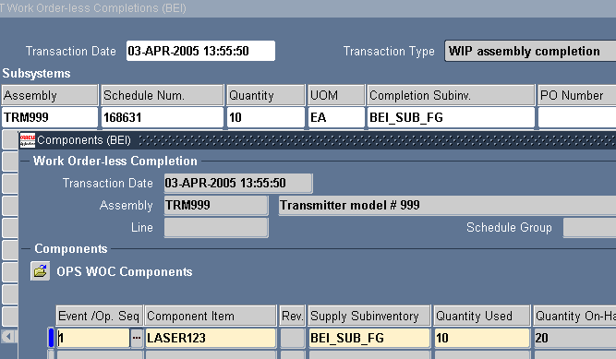
Figure 13 – Example # 4: Work Order-less Completion (Costing Deferred)

The completion of 10 units of TRM999 and the consumption of 10 units of LASER123 are recorded immediately upon entry of the Work Order-less Completion transaction on April 3rd. Both inventory transactions, however, remain uncosted until April 6th, because the transaction date is after the cost cutoff date.

The standard costs for Example # 4 are:

- Component Standard Cost for LASER123:
  - $1,200 per unit through the end of March 2005.
  - $1,000 per unit starting April 1st (changed via standard cost update on 04-APR-2005)
- Outside Processing Resource Charge:
  - $50 per unit through the end of March 2005.
  - $30 per unit starting April 1st (updated by user on 04-APR-2005; refer to Figure 14)
- Final Product Standard Cost for TRM999 (derived through assembly cost rollup):
  - $1,250 per unit through the end of March 2005 [$1,200 + $50].
  - $1,030 per unit starting April 1st [$1,000 + $30] (changed via assembly cost rollup and standard cost update on 04-APR-2005)

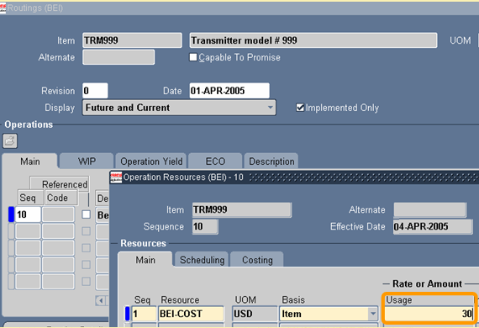
Figure 14 – Per Unit Resource Rate for Outside Processing Accrual

When the assembly cost rollup is run for item TRM999 on April 4th, a rolled-up pending cost of $1,030 is derived, as shown in Figure 15, from the new component cost of $1,000 plus the new outside process resource charge of $30.

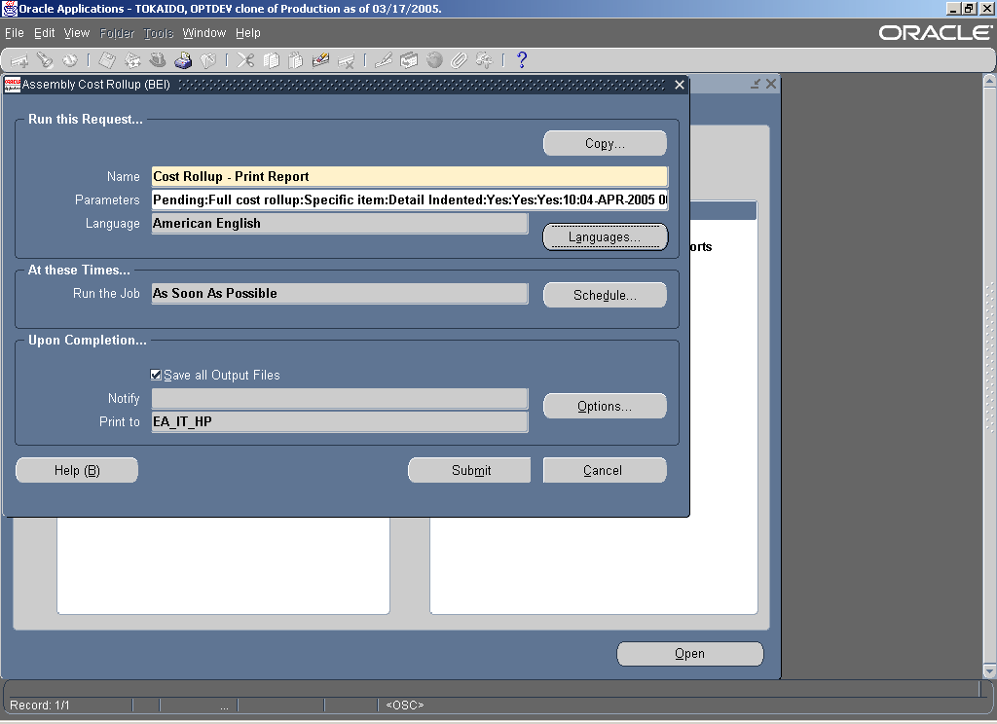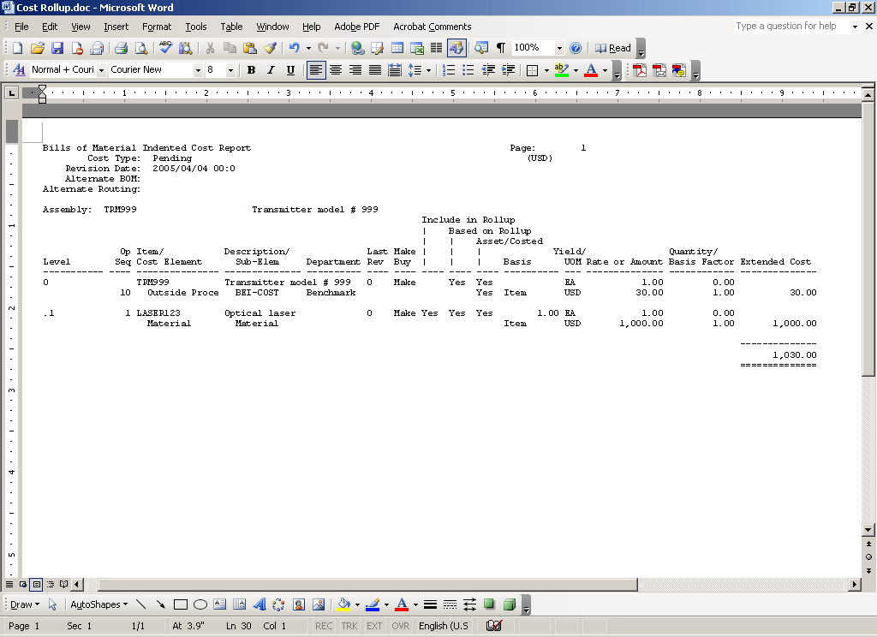
Figure 15 – Cost Rollup for Finished Good to be Made via Work Order-less Completion

Next, a standard cost update will be run on April 4th for all items in the organization. This cost update will change the frozen cost of TRM999 from $1,250 to $1,030. Material distributions are created in the Inventory module on April 6th using the new period costs. Material distributions for the outside processing charge are recorded in the WIP module on April 6th.
Lessons Learned: Impact on Reports

Most standard inventory reports are not affected by having uncosted transactions when the reports are run. Material distributions, of course, are not created until a transaction has been costed and will not, therefore, appear on inventory accounting reports.

One lesson Opnext learned by using the cost cutoff date functionality was its adverse impact on historical balances on a key standard Inventory report, “Transaction Historical Summary” [short name INVTRHAN version 115.13]. Opnext discovered in the release 11.5.8 and 11.5.10 versions of this reports that an item’s beginning balance might be inaccurate when the cutoff date is causing the item to have uncosted transactions, especially WIP completions or WIP component issues.

The report, in Opnext’s case, failed to estimate the value of some uncosted WIP transactions when backing into an item’s historical balance. This report derives an item’s balance on a historical date by valuing the item’s current quantity on hand using the current frozen standard cost. The report then subtracts the value of all material transactions for the item to back into its balance as of the historical date. If the item has uncosted transactions, the report uses a “proxy” cost, most often the frozen cost of the item on the transaction creation date, to estimate the transaction value.

Opnext found that its versions of this standard report valued some uncosted WIP transactions at zero. Figure 16, for example, shows the Transaction Value Historical Summary report created on 03-APR-2005 when item LASER7777 had an uncosted WIP component issue transaction. A $-480,000 estimate of the uncosted WIP component issue of LASER7777 is missing from the Job or Schedule column. As a result, the 28-FEB-2005 value of $-480,000 is incorrect; the balance should be zero.

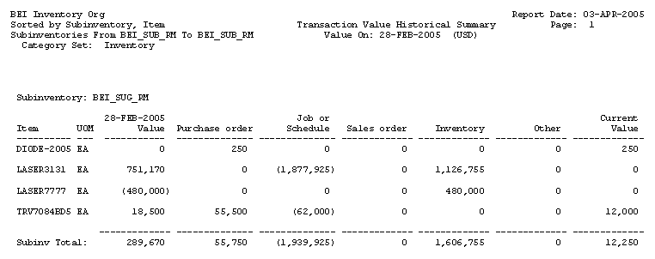
Figure 16 – Transaction Value Historical Summary Report with Incorrect Beginning Value

Fortunately, the inaccuracies in this report are corrected when the report is rerun after the cost cutoff date is changed to a future date and all uncosted transactions become costed. Figure 17 shows the report when it was rerun on April 7th, after the cost cutoff date was changed to a future date and item LASER7777 no longer had any uncosted transactions. This April 7th version of the report derives the correct 28-FEB-2005 value of LASER7777, because it reflects a non-zero value for the WIP component issue transaction dated between 01-APR-2005 and 03-APR-2005.

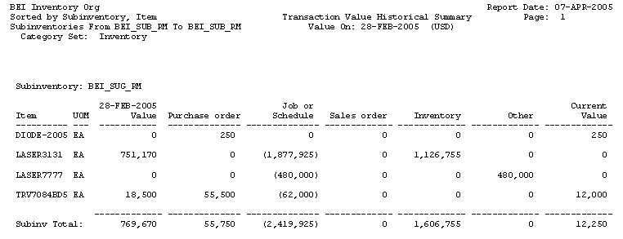
Figure 17 – Transaction Value Historical Summary Report with Correct Beginning Value

Opnext tried unsuccessfully in 2004 to have Oracle Support to address this report issue. But Oracle Support never acknowledged the bug in Opnext’s instance [reference: Metalink bug # 3585268 and 3585271].

Lessons Learned: Impact on Intercompany Invoicing

Another lesson learned was the positive impact that the cost cutoff date functionality had on the creation of Intercompany AR Invoices when a customer sale is sourced from a different operating unit. Intercompany Invoicing is standard functionality in EBS 11i and is sometimes referred to as Internal Drop Shipments. The intercompany invoicing occurs when the “shipping” operating unit is different from the “sales” operating unit and both operating units are linked through an intercompany relation. This condition is met when the inventory organization, or warehouse, from which a sales order is sourced is associated with an operating unit that differs from the operating unit in which the sales order is entered.

The “Create Intercompany AR Invoices” program does not create a record until its parent record has been costed. This parent record is the underlying shipment – the “Sales order issue” material transaction type [action = “Issue from stores”] when the warehouse ships the order. The cost cutoff date, therefore, indirectly defers the creation of the intercompany receivables invoice in the new cost period, because the cutoff date directly defers the costing of the “Sales order issue” parent record.

The creation of the intercompany payables invoice in the “sales” operating unit, furthermore, is dependent on the creation of the corresponding intercompany receivables invoice. So the cost cutoff date also indirectly affects the creation of the intercompany payables invoice.

Figure 18 shows the flow for an example where an external customer sales order in the Japan Sales operating unit is sourced and shipped from a U.S. inventory organization that is associated with the U.S. Manufacturing operating unit.

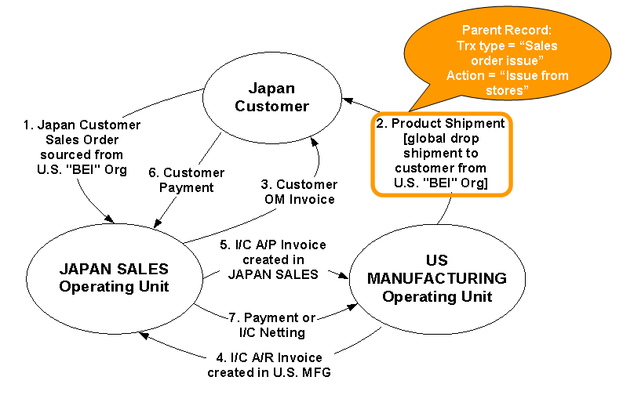
Figure 18 – Intercompany Invoicing Flow for Customer Sales Order Shipped from Different Operating Unit

The transaction flow for Figure 18 is:
- The customer order in the Japan Sales operating unit is sourced against the BEI inventory organization, which is associated with the U.S. Manufacturing operating unit.
- The product for the Japan customer order is shipped from the BEI inventory organization. This transaction has a type = “Sales order issue” and action = “Issue from stores”. If the cost cutoff date for BEI is deferring the costing of this transaction, then the “Create Intercompany AR Invoices” program will not create an invoice in step 4 until this “Sales order issue” transaction has been costed in BEI.
- The customer invoice in the Japan Sales operating unit can be created via AutoInvoice once the “Sales order issue” transaction in step 2 has been created, regardless of whether the “Sales order issue” has been costed.
- The “Create Intercompany AR Invoices” program creates an intercompany receivables invoice in the US Manufacturing operating unit. The invoice will not be created until the “Sales order issue” transaction in step 2 has been costed. The customer on the invoice is intercompany customer “Opnext Japan”. The invoice is valued from a price list defined for the customer location selected in the intercompany relation. The program uses the price from that price list which is in effect as of the creation date of the intercompany invoice, even though the transaction date of the invoice might be an earlier date; the invoice transaction date is set to the same transaction date as the “Sales order issue” in step 2.
- The “Create Intercompany AP Invoices” program creates an intercompany payables invoice in the Japan Sales operating unit. The payables invoice will not be created until the intercompany receivables invoice has been created in step 4. The payables invoice is valued at the same amount as the intercompany receivables invoice in step 4. The supplier on the invoice is intercompany vendor “Opnext U.S.”.
- The Japan customer payment is received. This is dependent only on the completion of step 3 and may occur before or after step 7.
- The U.S. Manufacturing intercompany receivable and corresponding Japan Sales intercompany payable are relieved through a wire transfer payment or a manual intercompany netting process. This is dependent on the completion of steps 4 & 5 and may occur before or after step 6.

The deferring of the intercompany receivables invoice creation allows Opnext to update the price list used to value the intercompany sales and payables transactions after April 1st or October 1st. Opnext updates these transfer prices every six months at the start of a new cost period. Because Opnext’s intercompany prices are transfer prices derived from the new standard costs, the new period transfer prices might not be set until the second week of April and October.

Opnext enters its new transfer prices with a 03-APR or 03-OCT start date as shown in Figure 19 below. This allows the “Create Intercompany AR Invoices” program, for example, to create March 2005-dated intercompany invoices through April 3, 2005 using the old period transfer prices with end date of ’03-APR-2005’. All April 2005-dated intercompany invoices will be valued using the new period transfer prices so long as the cost cutoff date of the ship from organization does not cost the April-dated “Sales order issue” transactions until April 4th or later.

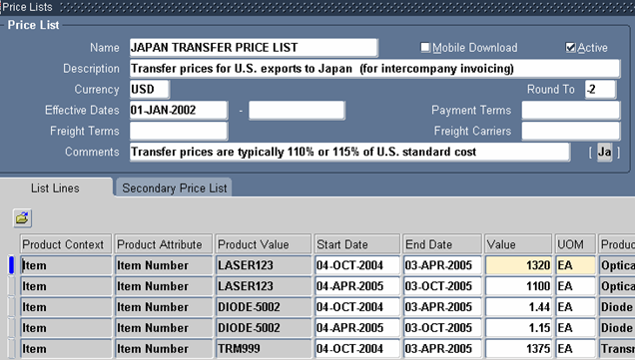
Figure 19 – Price List Used to Value Intercompany Invoices

Conclusion

The cost cutoff date functionality introduced in release 11.5.7 is a wonderful enhancement that eliminated Opnext’s need to record transactions outside of EBS 11i during the first few weeks of a new cost period. The functionality is very easy to configure in an inventory organization and appears to be simple to understand. Yet, users responsible for standard cost updates and intercompany price lists should understand the relationship of uncosted transactions to intercompany invoicing and the potential impact on the accuracy of historical balances on standard inventory reports.
Additional Resources

What is the Cost Cutoff Date? [Metalink note # 213628.1]

INVTRHAN: HISTORICAL DATA QTY=0 BUT THE VALUE IS > 0. [Metalink bug # 3585271]

11I INCIAR GETS APP-5706 WHEN RUN ON END DATE OF PRICES APP-05706. [Metalink bug # 3480557]

Workorderless Completion for Simple Outside Processing in 11i WIP. Eric Guether. OAUG Connection Point 2004 presentation.

